**Test Report:**

**Registration form Testing (Facebook)**

**1. Module Name:**

**Registration form Module**

**2. Objective:**

To verify that the Facebook registration system correctly detects and blocks multiple suspicious or invalid sign-up attempts, preventing automated or abusive account creation, and displaying an appropriate error message to the user.

**3. Environment Details:**

OS :- Windows 10, Windows 11, Linux, Mac OS, Android

System :- Laptop / Desktop / Smartphone

**4. Test Scenarios Covered:**

1. Verify all required fields validation
2. Validate first name field with numbers
3. Validate last name field with numbers
4. Invalid email format
5. Password length check
6. Invalid date of birth
7. Invalid mobile number
8. Tab navigation order
9. Check first name field length limit
10. Duplicate email check
11. Verify system behaviour after multiple consecutive failed registration attempts.
12. Successful registration

**5. Test Case Results:**

Test case ID :- 1

Test scenario :- Verify all required fields validation

Test Input :- Empty fields

Steps :- Leave all fields empty and click Sign Up

Status :- Pass

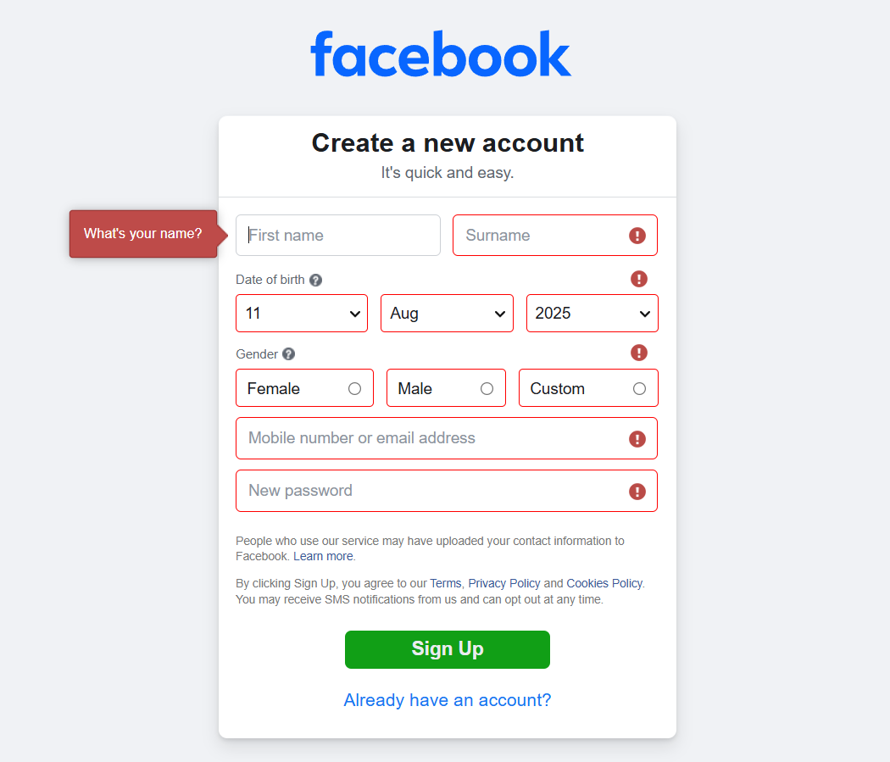

Test case ID :- 2

Test scenario :- Validate first name field with numbers

Test Input :- nayan123

Steps :- Enter nayan123 in First Name

Status :- Pass

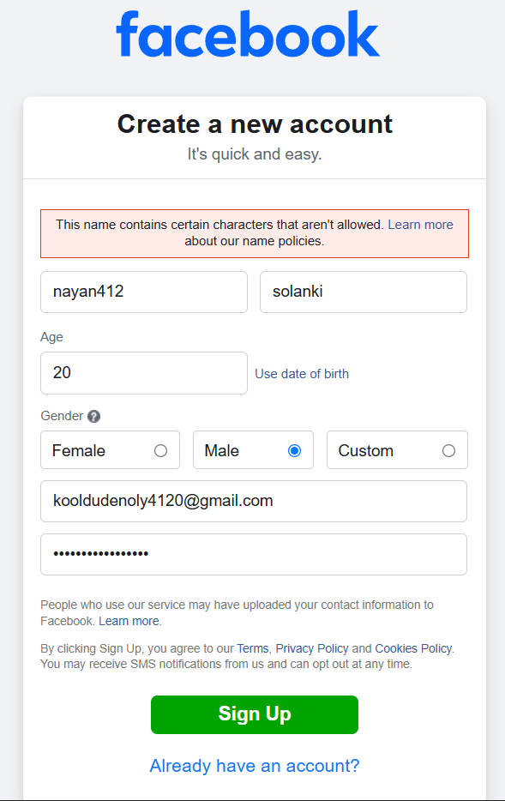

Test case ID :- 3

Test scenario :- Validate last name field with numbers

Test Input :- solanki123

Steps :- Enter solanki123 in First Name

Status :- Pass

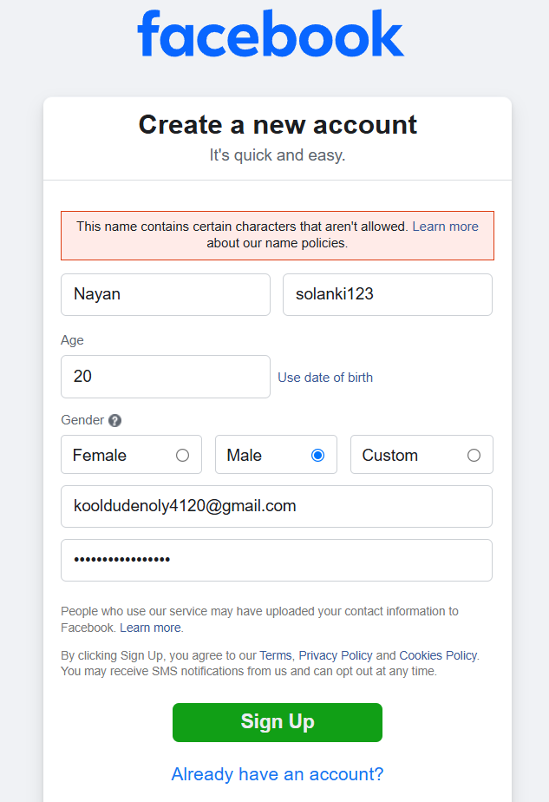

Test case ID :- 4

Test scenario :- Invalid email format

Test Input :- abc@

Steps :- Enter abc@ in Email field

Status :- Pass

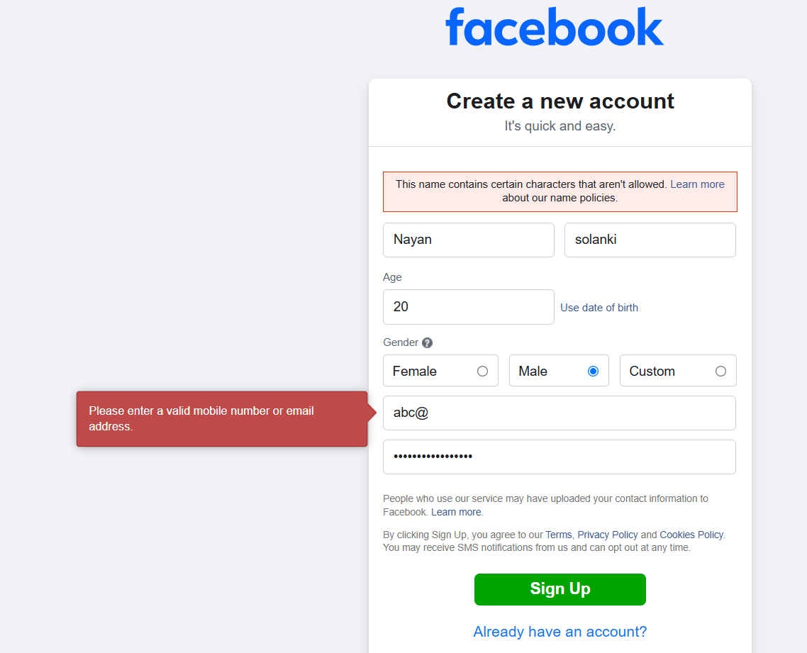

Test case ID :- 5

Test scenario :- Password length check

Test Input :- 12345

Steps :- Enter password less than 6 characters

Status :- Pass

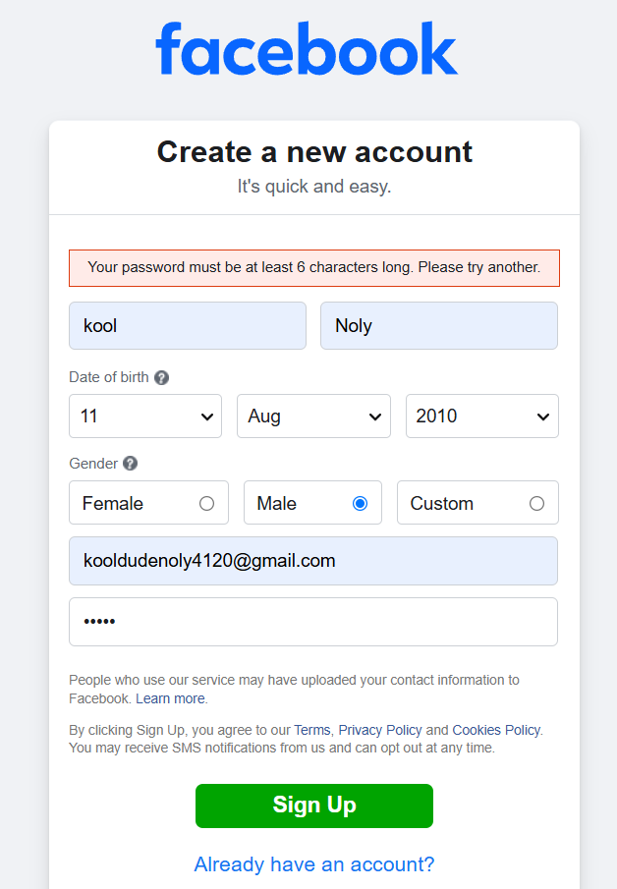

Test case ID :- 6

Test scenario :- Invalid date of birth

Test Input :- 31st February

Steps :- Select 31 Feb

Status :- Pass

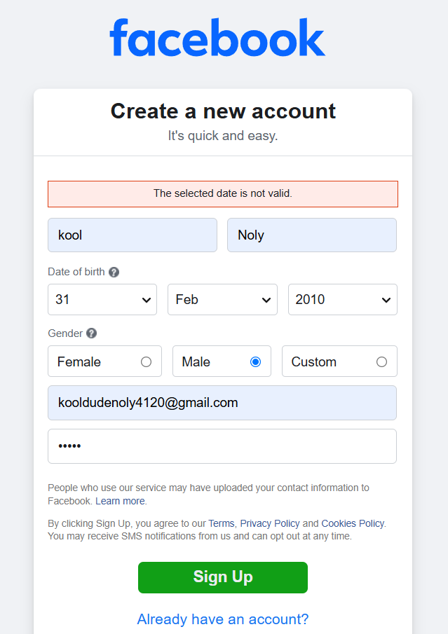

Test case ID :- 7

Test scenario :- Invalid mobile number

Test Input :- 123456

Steps :- Enter 1234556 in Mobile field

Status :- Pass

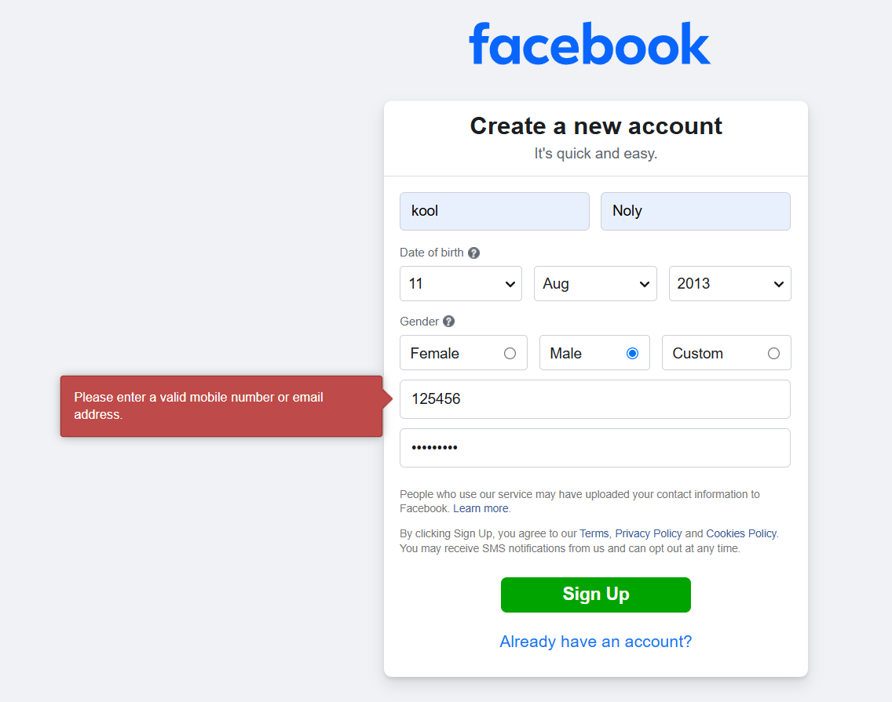

Test case ID :- 8

Test scenario :- Tab navigation order

Test Input :- Press tab key

Steps :- Use Tab key through fields

Status :- Pass

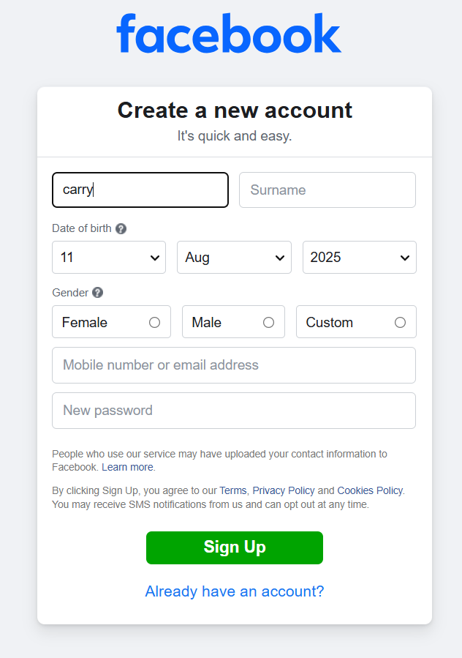 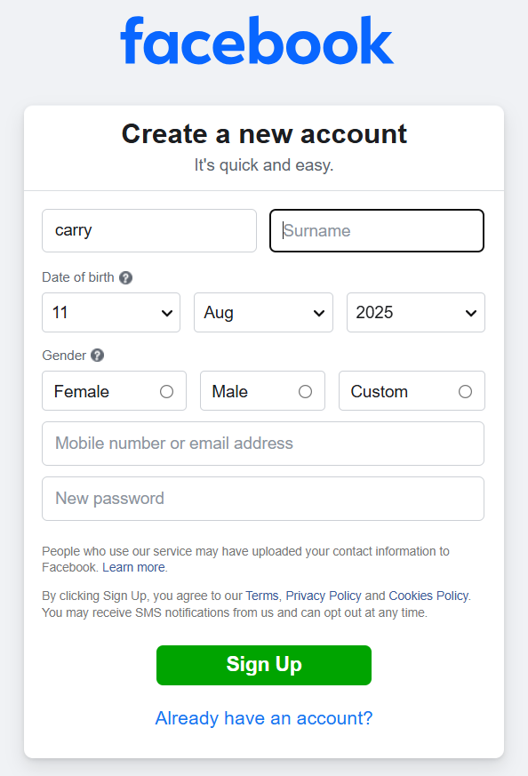

Test case ID :- 9

Test scenario :- Check first name field length limit

Test Input :- 60 characters

Steps :- Enter 60 characters in First Name

Status :- Pass

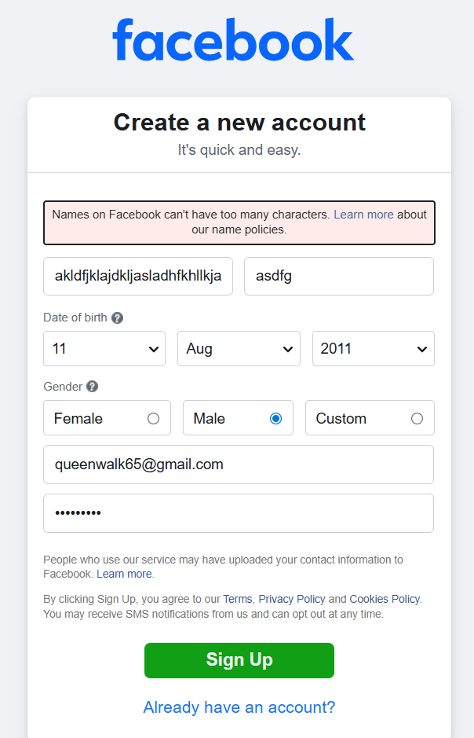

Test case ID :- 10

Test scenario :- Duplicate email check

Test Input :- kooldudenoly4120@gmail.com

Steps :- Enter an email already registered

Status :- Pass

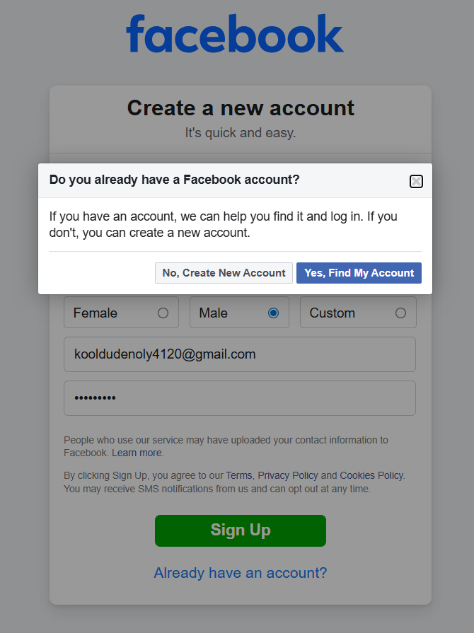 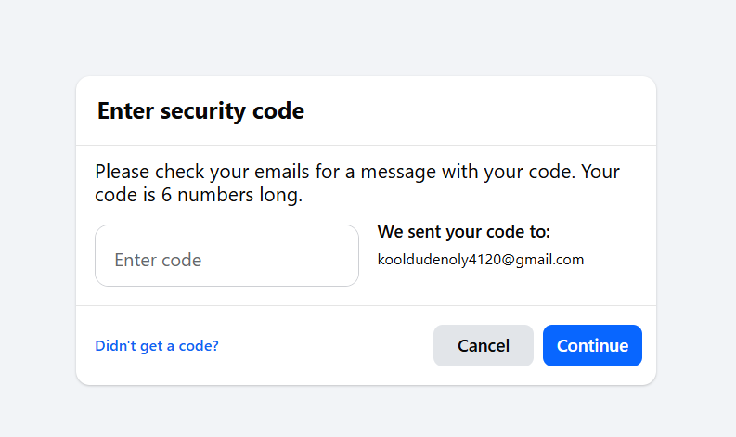

Test case ID :- 11

Test scenario :- Verify system behaviour after multiple consecutive failed

registration attempts.

Test Input :- Wrong inputs

Steps :- 1. Open the Facebook registration form.

2. Enter invalid or suspicious details (e.g., fake name, disposable

email) multiple times.

3. Submit the form repeatedly."

Status :- Pass

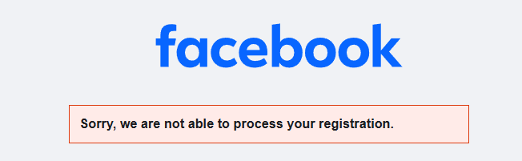

Test case ID :- 12

Test scenario :- Successful registration

Test Input :- Valid details

Steps :- Enter all valid details

Status :- Pass

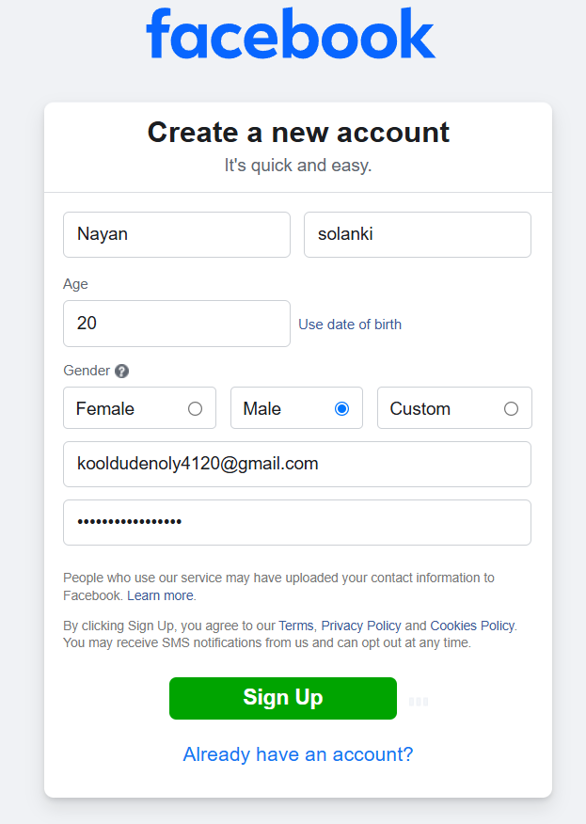

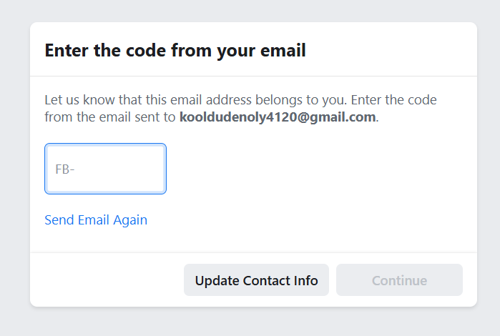

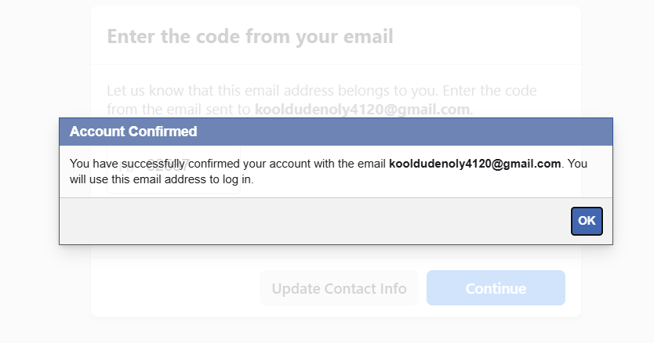

**Summery of Test Results :**

Total test :- 12

Passed :- 12

Fails :- 0